# **Yum Downloader**

**Steps To Use Yum Downloader:**

1. Install the yum-utils package.

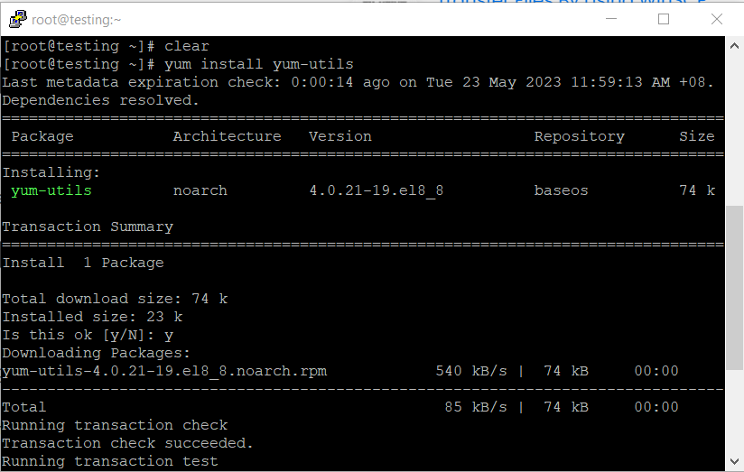

|  |
| --- |
| yum install yum-utils |

1. Run yumdownloader command followed by the desired package. For an Example yumdownloader gimp.

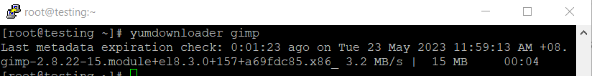

|  |
| --- |
| yumdownloader gimp |

1. By default, the package is saved in the current working directory. To provide a different location, use the --destdir option.
2. In case you need to download dependencies, be sure to add --resolve. To install downloaded packages, make sure to include --nodeps or --disablerepo=* at the end of rpm -ivh <Your RPM> command to avoid dependency checking.